**IDEATION PHASE**

**BRAINSTORM AND IDEA PRIORITIZATION**

|  |  |
| --- | --- |
| Date | 9 October 2022 |
| Team ID | PNT2022TMID51074 |
| Project Name | AI Based Discourse for Banking Industry |
| Maximum Marks | 4 Marks |

**Brainstorm & Idea Prioritization:**

**Step-1: Team Gathering, Collaboration and Select the Problem Statement**

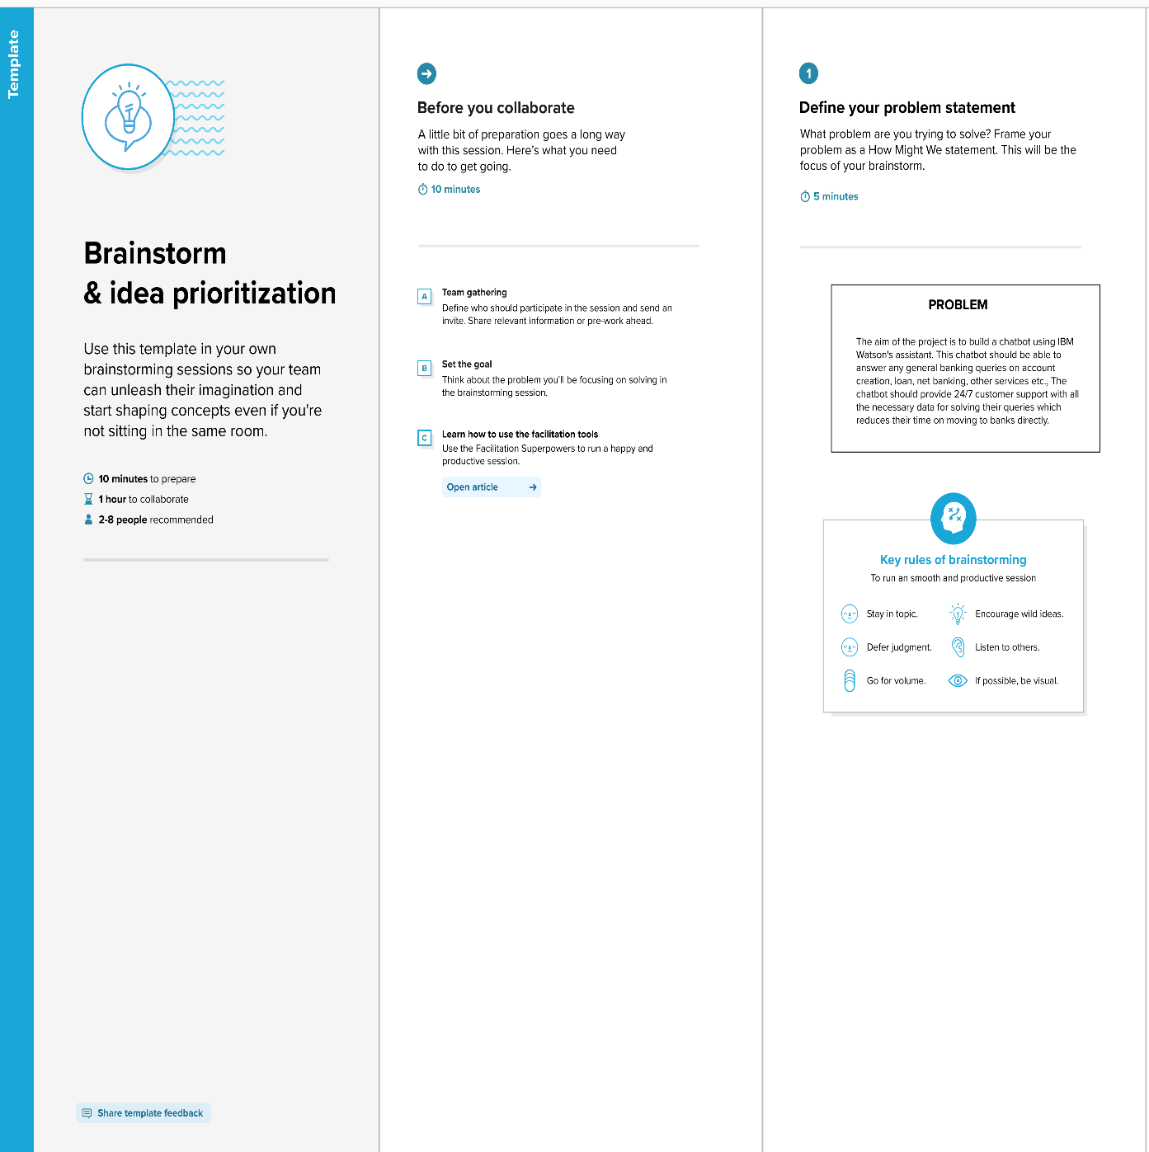

**Step-2: Brainstorm**

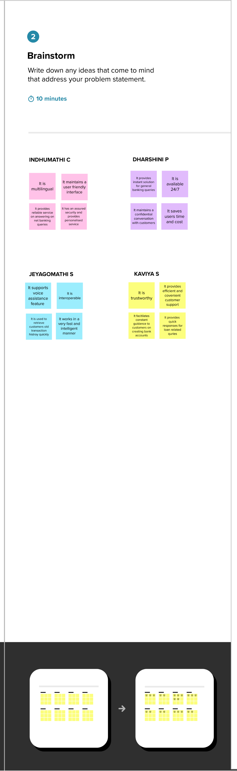

**Step-3: Idea Priori**

**Step-3: Group Ideas**

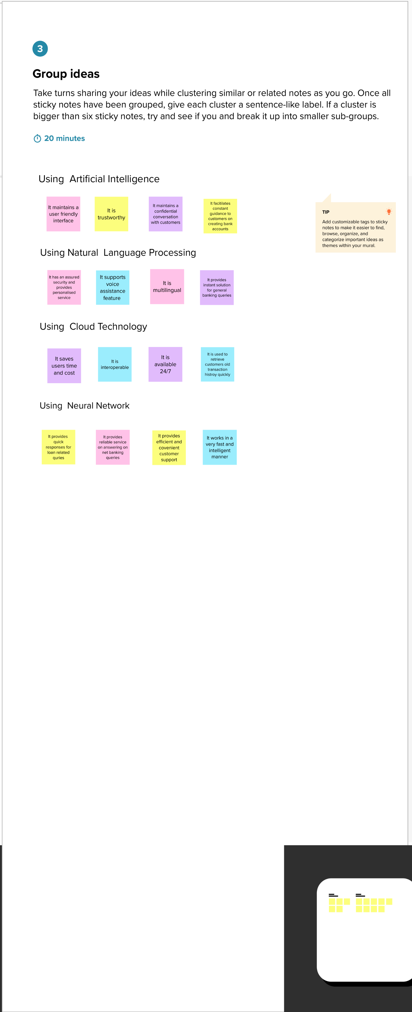

**Step-4: Idea Prioritization**

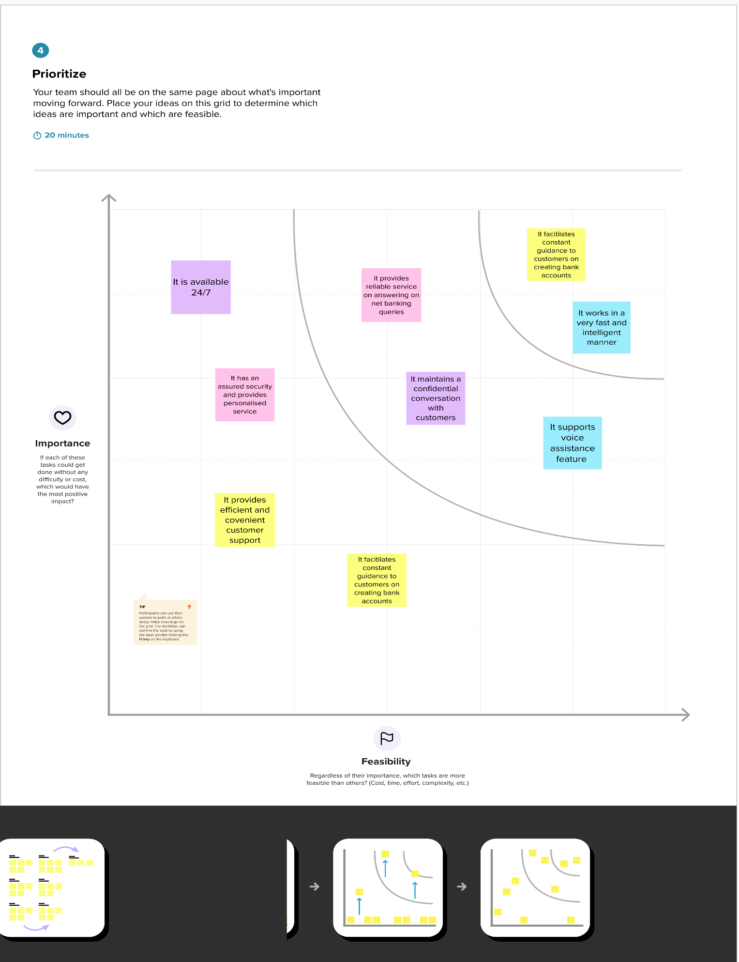

**The Brainstorming and Idea Prioritization:**

[**https://app.mural.co/invitation/mural/aibaseddiscourseforbankingin9468/1665248889008?sender=u829c9b26bf051cc02e3a5968&key=83d21621-c5da-4daa-8eb1-04fdac75bee0**](https://app.mural.co/invitation/mural/aibaseddiscourseforbankingin9468/1665248889008?sender=u829c9b26bf051cc02e3a5968&key=83d21621-c5da-4daa-8eb1-04fdac75bee0)